- Analyse your assigned equation. What is the dependent variable, what are the independent variables? Name the variables, describe in what form they are included (levels, log, first differences …) and give some intuition for why the equation might be set up in the way it is. Check Table 1 and the appendix of the research paper for how the variables are defined. Anything noteworthy or surprising? [1 mark]
I have been assigned stock of inventories the dependent variable for this equation is change in the stock of inventory (${∆kv}_{t})$ in log first difference form. The independent variables included are log of lagged stock of inventories ${(kv}_{t-1})$ and log of lagged real GDP ${(Y}_{t-1})$. The change in stock of inventories (${∆kv}_{t-1})$ from the previous period is in form Lagged log difference. Coefficient four includes three variables all are in levels form and show growth rates which flow from quarter to quarter. Trend labour productivity growth (TDLLA), Trend population growth (TDLLPOP), and Trend change in average hours worked per employee (TDLLHPP). The content term is negative due to the depreciating nature of inventories and equipment. The inventories equation (46) is set up so that the second coefficient is fixed at -0.001 being error correction term for long-run inventory to output ${[(kv}_{t-1})-{(Y}_{t-1})]$, being negative, it reverts to the mean. The ${∆kv}_{t-1}$ provides a view into changes in inventories, it is lagged so it suggests change is more gradual for firms to purchase more inventory as they need borrowing capacity and planned decisions to expand or replace equipment. The fourth coefficient is restricted by the third coefficient and accounts for growth in the economy, racking trend productivity, hours worked, and population growth, together it makes sure the model does not outpace output in the long run.
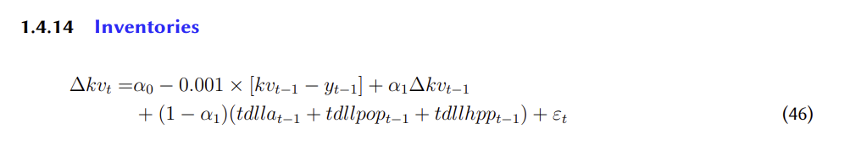
It is noteworthy that $∝_{0}$ is not estimated but fixed and that coefficient four is restricted to (1-$∝_{0})$. It is surprising that the model is very simple and that there are no interest rate or business confidence levels variables associated with borrowing and financing new equipment and inventories.

- Plot all the data series used in your equation. Discuss any salient features. Are there clear outliers? Was your equation affected by the COVID-19 crisis in an obvious way? [1 mark]
The stock of inventory (kv) plot has a very volatile upward trend. In contrast real GDP (Y) trends upward smoothly, noticeably these two variables move together. Trend labour productivity growth (TDLLA) is decreasing over the timeframe, illustrating Australia’s productivity slump especially from the late 1990s to the present. Trend change in average hours worked per employee (TDLLHPP) has consistently been negative over the whole time period. Trend population growth (TDLLPOP) has fluctuated overtime and has been increasing since 2020. The 1990s recession saw large drop in the kv and the GFC saw a substantial drop in kv. In 2019 a large drop in kv (supply chain problems with the alert of covind-19 prompting countries to close boarders) but followed by a very large sharp increase in the kv level. Covid-19 created a large outlier in 2020 illustrating a large drop in GDP but followed by a sharp rebound in GDP. the equation effected by covid-19 it looks to be affect around 2021-23, not immediately at the beginning of 2020.
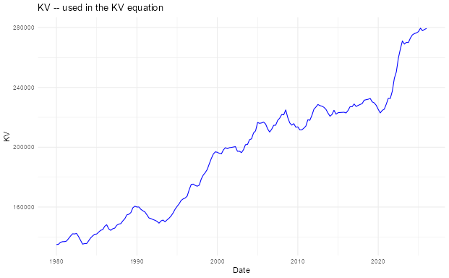

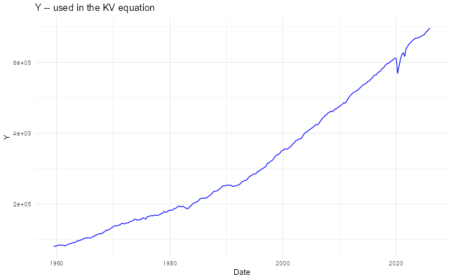
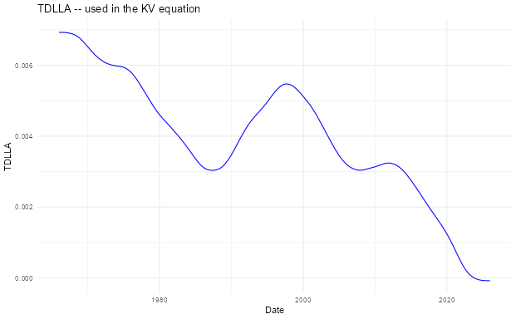

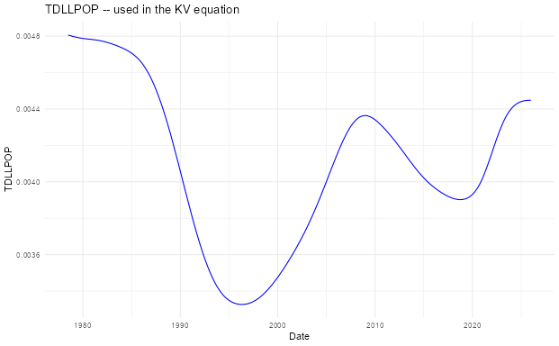
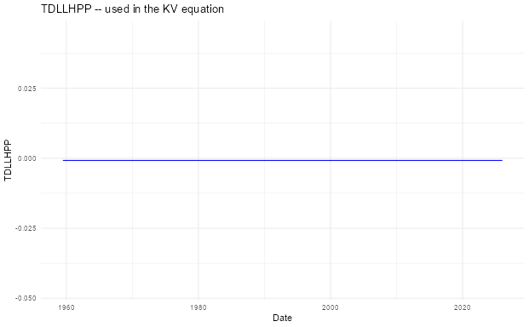

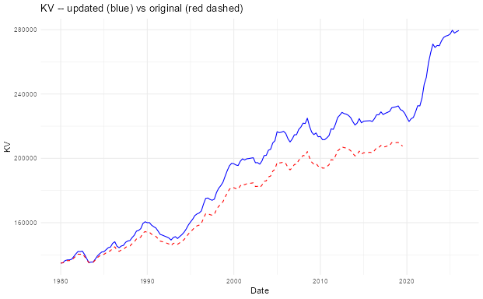

- Estimate your equation over the original sample ending in 2018 Q2. This replicates the RBA’s MARTIN model estimation. Discuss the parameters estimated and the residuals (plotting them first). [1 mark]
The constant $∝_{0}$ was -0.00291, the error correction term is fixed at -0.001, The third coefficient $∝_{1}$ was 0.3869 showing lagged growth and the fourth coefficient was 0.6131 (${1-c}_{3}=c_{4})$. All coefficients were individually significant at 1%, the $R^{2}$ was 0.1645 and the Sum of squares of residuals was 0.00764. The Residuals for the original sample group are around $±0.01$ this is consistent with the standard error of regression being 0.0071. The single biggest outlier (-0.027) occurred around 2008 due to the GFC where a large drop in the stock of inventories, that the model did not predict. Post GFC the residuals oscillate around 0 and ensures the model is still accurate.
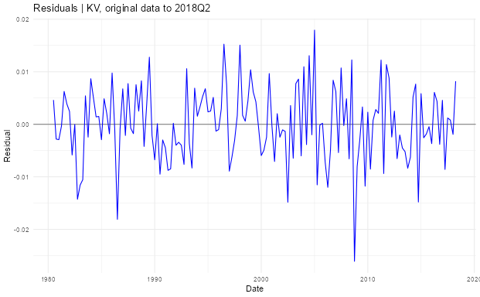

- Re-estimate on the updated data extended to 2026 Q1. Two things change at once — longer sample, and revised/re-referenced data, as in Assignment 1. Discuss how the parameters and residuals change, if they do (plotting them first). [1 mark]
The constant $∝_{0}$ was -0.002026, a smaller shift from the baseline in comparison with the original sample. The error correction term is fixed at -0.001, the third coefficient $∝_{1}$ was 0.458, placing a higher weight on previous quarter growth. The fourth coefficient was 0.542 (restricted by ${1-c}_{3}=c_{4})$.All coefficients were individually significant at 1% except $∝_{0}$ which was significant at 10%. The $R^{2}$ was 0.1933 showing the model had a greater fit with updated sample, additionally the sum of squares of residuals rose to 0.015098 as there was a greater number of outliers. The Residuals for the updated sample extended to 2026 quarter 1 shows an additional positive outlier around 2022-23 (Large stimulus package program to purchase new inventories/equipment’s, as well as the instant asset right off scheme). The updated sample group around $±0.02$ this is consistent with the standard error of regression being 0.00913 (large increase compared with the original samples 0.0071). There are now substantially more spikes that exceed $±0.01$, with a negative residual in 2008 exceeding -0.03.
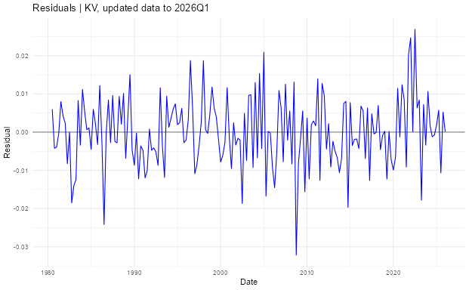

- Propose changes to the equation (additional controls, indicator variables, a different lag structure …), estimate the new version, and discuss whether it improves on the baseline. [1 mark]
The constant $∝_{0}$ was -0.001889 an even small shift from the baseline compared with 2026 sample. The second coefficient was -0.001 (restricted). The third coefficient $∝_{1}$ was 0.32678 a reduction from 0.458 as the dummy variables have removed the outliers post covid, which had greater previous quarter growth. The fourth coefficient was 0.6733 (restricted by ${1-c}_{3}=c_{4})$, now three dummies have been added to the model, the GFC, the early 1990s recession and the 2022-23 post covid growth. All three coefficient were statistically significant with the post covid dummy having the greatest significance. The $R^{2}$ was 0.2930 showing an even greater model fit the original 2026 sample data and the sum of squares of residuals are 0.01323 is small than the 2026 baseline, after the dummy variables removed outliers from the model. The residuals in updated sample group with dummy variables are around $±0.015,$ this is consistent with the standard error of regression being 0.00862 a decrease of 5.60% from 00913. The dummy model shows an improvement compared with the original 2026 sample, but still has room to improve, for instance the addition some control variables such as business confidence levels and interest rates as they are indictive of a firm ability to borrow and finance.
